First, let's create a new shuttle project

Then we need to add three imports to our file，

**import** 'package:flutter/cupertino.dart';

Cupertino is a widget that imitates IOS style，We use it to imitate IOS animation

import 'package:flutter/painting.dart';

The function of this import is to make our animation more accurate and smooth

**import** 'package:flutter_echart/flutter_echart.dart';

After adding, we click auto fix and it will automatically pub get. When we go to the yaml file, dependencies has automatically added echart for us

0xFFCADCED

Now let's go to the location where scaffold, and then Delete the contents

Widget build(BuildContext context) {

**return** Scaffold(

First add a background color

backgroundColor: Colors.white,

*Center the main content of the page*

body: Container(

width: MediaQuery.of(context).size.width,

height: MediaQuery.of(context).size.height,

child: Stack(

alignment: Alignment.center,

*Set the specific height, width, background and order here*

children: [

Container(

*//来个高度*

height: 260,

*//宽度填充*

width: MediaQuery.of(context).size.width,

*//设置一下背景*

color: mainColor,

*//封装一个方法构建左右排列的*

child: buildPieChatWidget(),

),

],

),

),

);

}

*Now we will add our table data here and what table show*

List<EChartPieBean> _dataList = [

Now we will define how the chart is displayed and what data it contains

EChartPieBean(title: "生活费", number: 200, color: Colors.lightBlueAccent), *This determines what color this part will be displayed in*

EChartPieBean(title: "游玩费", number: 200, color: Colors.deepOrangeAccent),

EChartPieBean(title: "交通费", number: 400, color: Colors.green),

EChartPieBean(title: "贷款费", number: 300, color: Colors.amber),

EChartPieBean(title: "电话费", number: 200, color: Colors.orange),

];

Now we will add methods to make the table display and set a series of parameters

PieChatWidget buildPieChatWidget() {

**return** PieChatWidget(

dataList: _dataList,

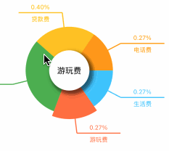 *This means whether to output the log. If we choose true, it will always display the drawing of animation on the terminal*

isLog:**false**,

*This means whether background is needed*

isBackground: **true**,

*This means whether the line in the picture is needed. If we select false, it will not display the line*

isLineText: **true**,

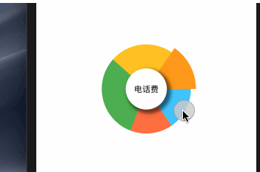  *background color*

bgColor: Colors.white,

*This line represents whether to display the middle circle. If false, it will not be displayed*

isFrontgText: **true**,

This command can select the part that is initially enlarged in the figure

initSelect: 1,

This tells the program to perform animation when the table is opened openType: OpenType.ANI,

*This is the animation of the table click*

loopType: LoopType.AUTO_LOOP,

*//点击回调*

clickCallBack: (int value) {

print("当前点击显示 $value");

},

);

}

}

Don’t forget

child: buildPieChatWidget(),

Most packages have a declaration of null safety, so we can run the program with flutter run, but this package does not have a declaration of null safety, so when we use flutter run, it will make an error

We need this line of code to start it

flutter run --no-sound-null-safety